# Ryan Hatch SNHU DAD 220 Analysis and Summary Template

1. **Analyze the data** you’ve been provided with to **identify themes**:
   1. Which parts are being replaced most?

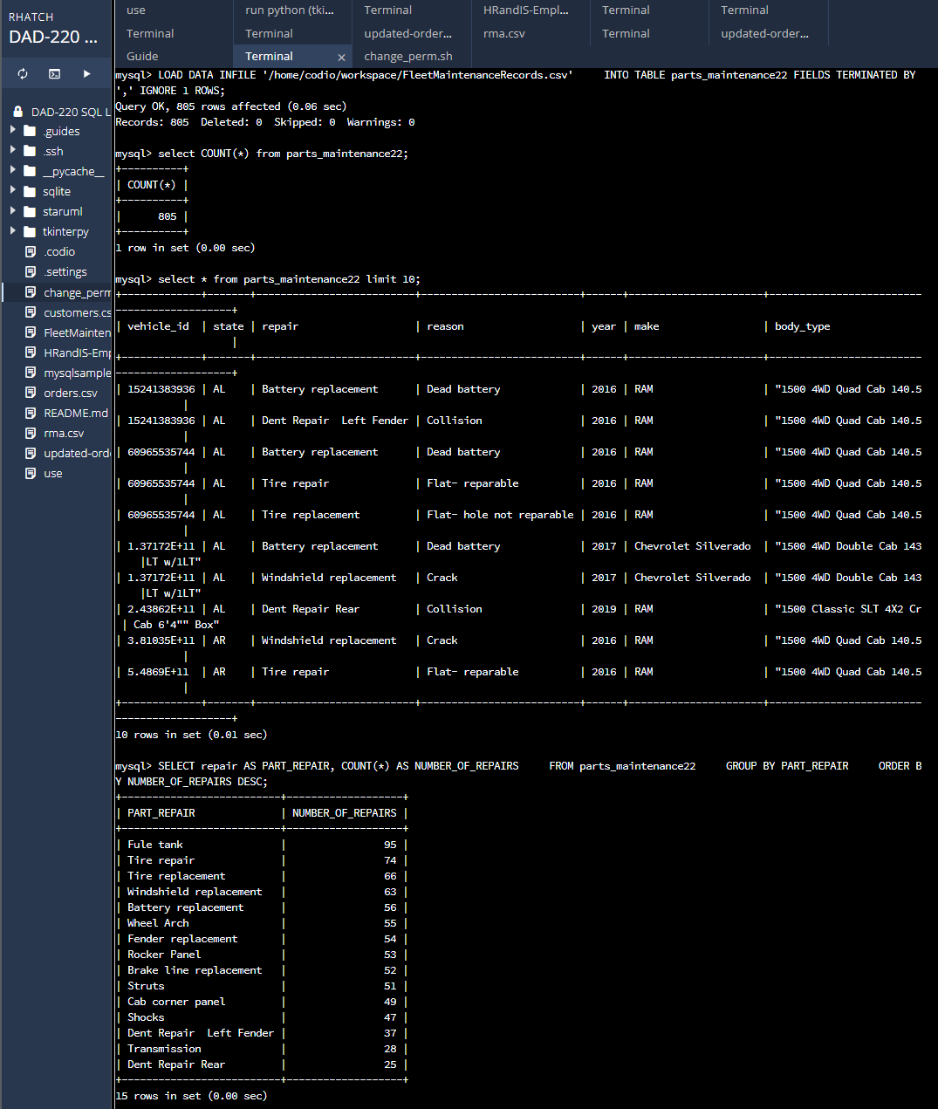

The most repaired or replaced part would be the Fuel tank at 95 numbers of repairs.

Is there a region of the country that experiences more part failures and replacements than others?

* + 1. Identify region: North East region is greater by 145 repairs.

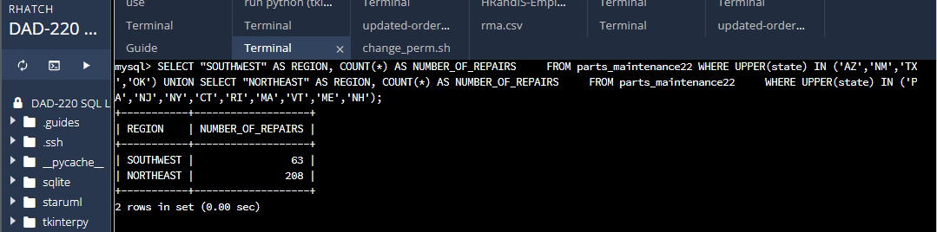

How might the fleet maintenance team use the information to update its maintenance schedule?

The fleet maintenance team can use this analysis in order to adjust the frequency of their visits to the Northeast region.

* 1. Which parts are being replaced most due to corrosion or rust?

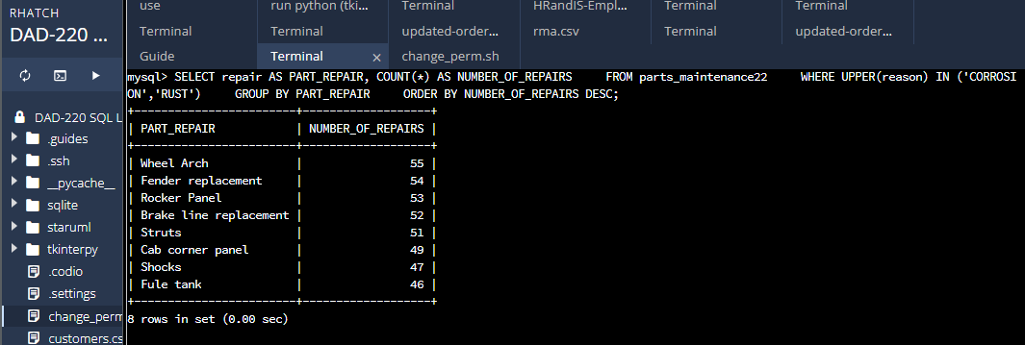  
  
The parts that are being replaced the most due to corrosion or rust is the wheel arch. The wheel arch currently has 55 repairs in the database. Replacing the fender, rocker panel, brake line, and struts are all high demand repairs that are also all over 50 repairs.

* 1. Which parts are being replaced most because of mechanical failure or accident, like a flat tire or rock through the windshield?  
       
     Tire repair, tire replacement and windshield replacements.

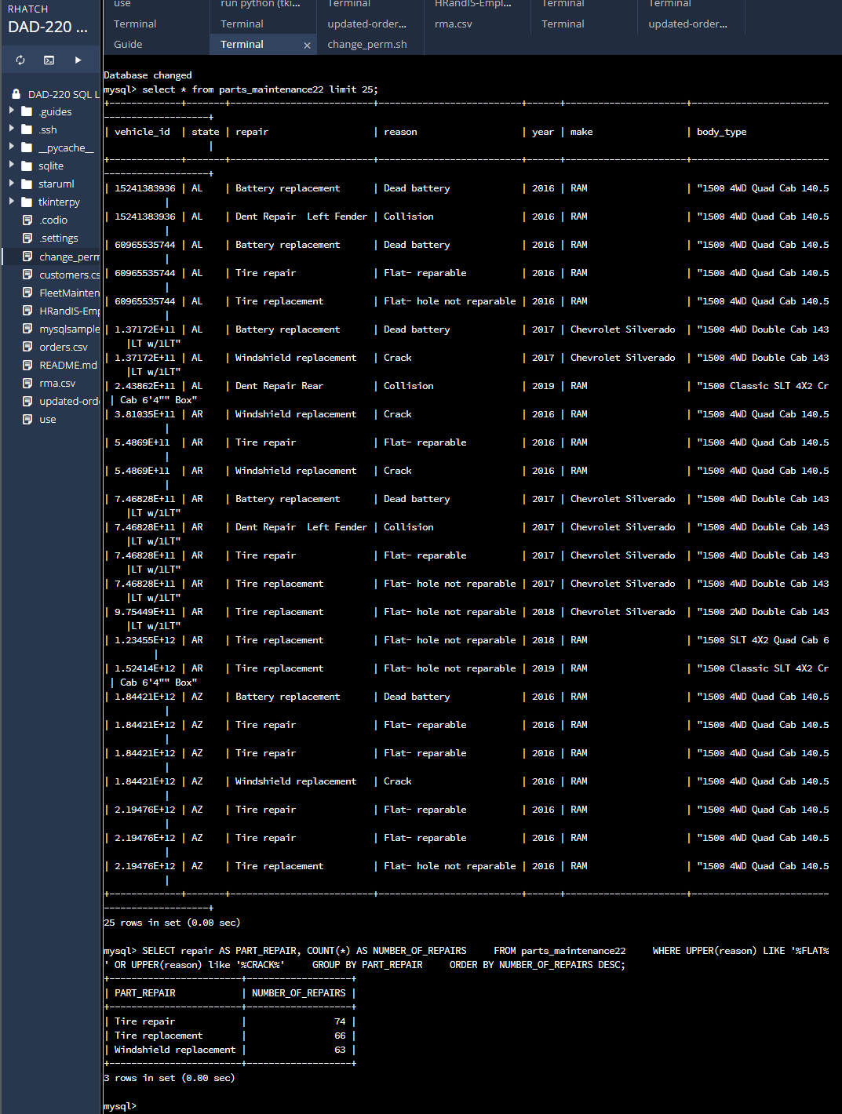

1. **Write a brief summary of your analysis** thattakes the information from Step 1 and presents it in a way that nontechnical stakeholders can understand.

By examining the data, we observed a clear pattern in repairs across different regions. The Northeast region stood out with a significantly higher number of repairs compared to other regions, totaling 208 repairs, while the Southwest had 63 repairs. These findings suggest that the Northeast region requires heightened attention and maintenance in terms of vehicle repairs.

To delve deeper into the reasons behind repairs, we focused specifically on instances related to corrosion and rust. Our analysis revealed that certain parts were more susceptible to these issues. The most commonly affected parts included the wheel arch, fender replacements, rocker panel, brake line, struts, cab corner panels, shocks, and fuel tanks. Identifying these areas of concern emphasizes the need for fleet management to prioritize proactive maintenance efforts in the Northeast region. By addressing these challenges promptly and effectively, we can enhance overall maintenance practices, extend the longevity of the fleet, minimize costs, and ensure reliable operations.

By presenting these findings and proposing targeted solutions, stakeholders can make informed decisions to optimize fleet management and mitigate potential risks associated with corrosion and rust.

1. **Outline the approach** that you took to conduct the analysis.
   1. What queries did you use to identify trends or themes in the data?

I created a table named “parts_maintenance22” with the appropriate columns to store the maintenance records before loading the data from the provided .csv file into the table I had created. I then conducted several queries to analyze the data and identify trends and themes.  
  
The first query was used to identify the number of repairs for each part in the fleet. The query provided a breakdown of the repairs by part and their respective counts, helping identify frequently repaired parts.  
The second query was used to focus on repairs related to flat tires and windshield cracks. This query was used to analyze the specific reasons for repairs, providing insights into the frequency of repairs related to flat tires and windshield cracks.  
Next, I grouped repairs by region (Southeast and Northeast) and analyzed the number of repairs within each region. The rest of this query allowed for a comparison of repair frequencies between the Southwest and Northeast regions, highlighting the region with a higher number of repairs.   
I then examined the repairs specifically related to corrosion and rust. This query helped identify the parts that were most affected by corrosion and rust, providing insights into the areas that require attention and proactive maintenance.

* 1. What are the benefits of using these queries to retrieve the information in a way that allows you to provide valuable information to your stakeholders?

The analysis provided a clear overview of the parts that require frequent repairs. This information helps stakeholders prioritize maintenance efforts and allocate resources effectively. Another benefit was that by narrowing down the analysis to specific regions for repairs, such as flat tires and windshield cracks, stakeholders gain a deeper understanding of most common issues and can take targeted actions to prevent or address those issues.  
Another benefit is the ability to analyze the comparison of repair frequencies between regions allows stakeholders to identify regions that require more attention and allocate resources accordingly, thus minimizing overall costs and optimizing maintenance efforts.   
  
The queries used in the analysis provided information that highlighted areas of concern, helped make informed decisions and optimize fleet maintenance practices.

1. **Explain how the functions in the analysis tool** allowed you to organize the data and retrieve records quickly.

The functions available in the analysis tool played a crucial role in organizing the data and reviving records efficiently. The “CREATE TABLE” function defined the structure of the table, ensuring the data was properly organized. The “LOAD DATA INFILE” function allowed for the quick bulk loading of data from the provided .csv file, saving time and effort. SELECT queries, coupled with the WHERE and ORDER BY clauses, facilitated in retrieving records and enabled data analysis. The use of aggregate functions and GROUP BY clauses provided valuable insights into repair frequencies, region comparisons, and specific repair reasons.   
  
In conclusion, these functions streamlined the process, allowing for organized data and quick retrieval of records, ultimately providing stakeholders with valuable information.